It’s Academic!
(What’s the letter? /Spell the word. /Name that knot.)
Similar to the kids TV show It’s Academic this game would be played in teams or sixes, racing against each other relay style. The theme or topic, just like the equipment used to play, is limited only to your imagination.
Some ideas for themes include:
  - Jungle book names
  - Knots
  - First aid
  - Promise & Law
  - Flags, Emblems & Flora/Fauna
  - Scouting History
Some ideas for equipment include:
- Scrambled letters which could be on balloons, blocks, balls, fridge magnets or laminated cards
- Laminated words (to Law & Promise, Jungle book names)
- Laminated pictures (of Jungle Book characters, state flora/fauna/flags)
- Basic first aid items (bandaids, slings, bandages)
- Ropes and diagrams of how to tie knots
- Laminated pictures of Lord Baden-Powell
- Numbers (to be used for important dates in Scouting history), could be laminated, fridge magnets, 2 dice which include 0, 7, 8 and 9)
- Set of questions on topics or themes
When setting the games, each Cub in the Six could be asked questions so that every Cub participates or you could set it that they work as a team to complete the task. You will need to keep in mind the abilities of the Cubs within the teams. Teams could be set out in Boomerang levels, so that Bronze, Silver and Gold each have questions or tasks to their ability and race against each other or be in actual Sixes.
SPIT IT OUT
Jungle Book game: Name That Character
- Cubs are to stand in 4 even teams (sixes) at one end of the hall.
- At the other end of the hall is a laminated card with a picture of a Jungle Book character and a box of building blocks with letters on them.
- Each Cub is to run down (in turn) to the picture and select one letter from the box to spell out the Character’s name and place it in one of the squares on the card - they then return to the end of the line.
- The next Cub is to run down and select another letter from the box and place it on the card and so on until the whole word is completed. The winning team is the first team to be finished and standing or sitting still and quiet.
Notes:
  - Jungles book names can be hard to spell, particularly for the younger Cubs. I have attached some 5 letter words, however if you have more than 5 in the team, you could choose 6 letter names or have the person that has not had a turn to tell you something about that character.
  - You might have the Sixer or Second go last so that they can check on the spelling.
  - Ensure you have enough of the correct letters needed plus many other letters not required to make it a little more complicated.

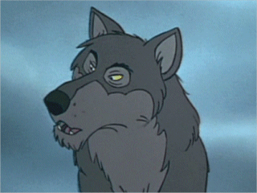

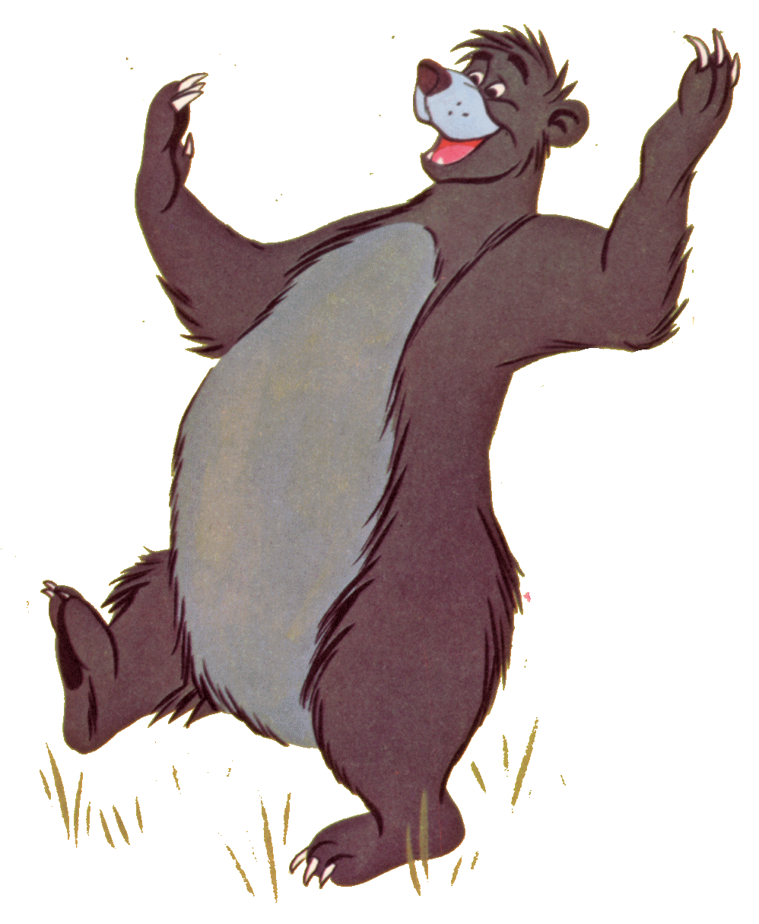

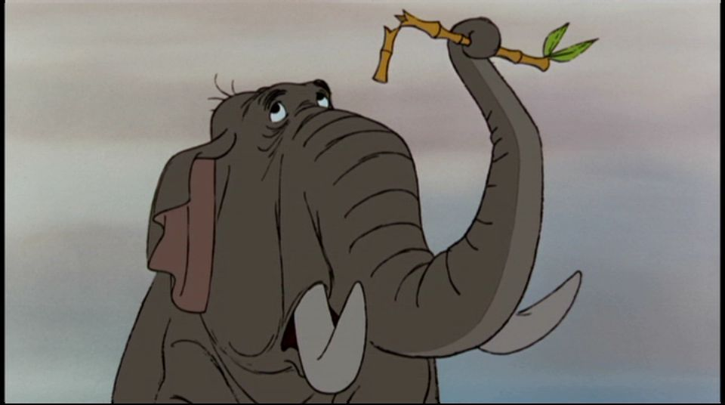

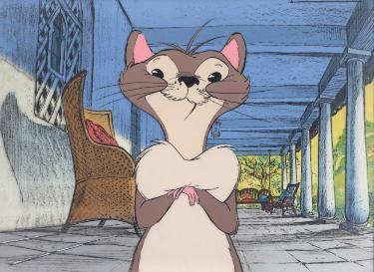

Knotting Game: Name That Knot (for bonus points – tie it!)

- Cubs divided into three even teams in Boomerang ability - Bronze, Silver and Gold.

- Cubs line up at one end of the hall. At the other end there are a number of balloons with letters written on them and a number of knotting ropes.

- Leader reads out the description of the knot only, without saying what the knot is called.

- In relay style, one Cub at a time, the Cubs run to the other end of the hall and collect one balloon at a time to spell out the name of the knot.

- Once spelt correctly, the Cubs will then run down and collect a knotting rope. The Leader will give them the instruction sheet to use if needed. For Bonus points, each Cub in the team needs to be able to tie that knot.

Notes:
  - Explain to Cubs the number of letters they need to collect and that the word Knot, Hitch and Bend is part of the full word.

  - You may need extra balloons with extra letters to cover any balloons that pop.

  - I have four knots attached, however I have run this with Bronze completing the Reef Knot, Silver completing the Clove Hitch and Gold completing the Sheet Bend.

Reef Knot

This knot is also known as a square knot. It is used for tying shoe laces. It is also used for tying the reefing points on a sail and for tying a triangular bandage in first aid.

Clove Hitch

This knot is usually used to start off a lashing. Except for this use, it is necessary that there is an equal pull on each end of the hitch.

Sheet Bend

This knot is used for tying two ropes together. Has better strength than the reef knot.

Bowline

This is a rescue knot. This is one of the most useful knots to know. Used for tying loop at the end of a rope. If you can tie this knot there is no knot that you can’t master!

Gabie Thompson DLCS
Hills South District
3rd August 2012

